News Article One: Times Square Shooting Suspect Charged with Attempted Murder

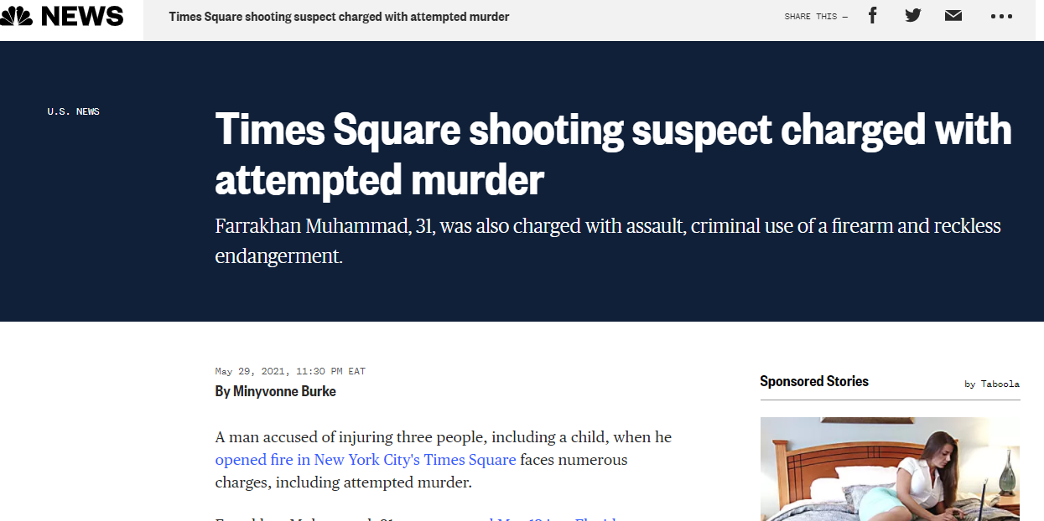

- Based on this article, the readers of this news need to take action because the issue is quite disturbing. The readers should always be careful whenever they are since cases of the shooting have risen over the years. Active shooters exist in various states. “A man accused of injuring three people, including a child, when he opened fire in New York City's Times Square faces numerous charges, including attempted murder.” Therefore, it is essential to take necessary actions to enhance safety.
- This news proves that there is an immediate threat to the public's safety at large. For instance, children and the elderly, among other individuals, are quite vulnerable to such cases of public shootings since they might find it hard to escape during such occurrences. Children indeed lack the skills to escape or flee during these instances.
- This crime has a significant effect on the community. For instance, the man in the news was charged with shooting three people. “Farrakhan Muhammad, 31, was captured May 12 in a Florida McDonald's parking lot after police say he shot Wendy Magrinat, 23; Mạrcela Aldana, 43; and Skye Martinez, 4.” Such act is a blow to the family members who might end up losing their loved ones. Also, such crimes instill fear in members of the community.
- The publication of this story can help to prevent these crimes because individuals will understand the consequences of such actions. For instance, the readers who have criminal intentions might change their behaviors when they observe the accused being arrested and charged for these crimes.
- This story helps to increase public understanding of the crime by providing the context of the criminal justice system. It reveals that the law enforcement agencies are working hard to arrest and prosecute any criminal in society.
- In conclusion, the publication of this article was on point since it is more informative to the entire society.

News Article Two: Woman Charged in Idaho Killing of her Children may face Arizona Charge in Death of Estranged Husband.
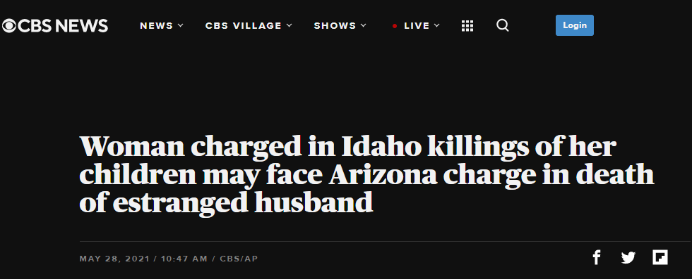
- The readers of this news article need to take action because this issue is very tragic. The article states, “Police say a woman charged in Idaho with murder in the deaths of her daughter and son after their disappearances should face an additional criminal charge in suburban Phoenix in the 2019 killing of her estranged husband.” The above quote is enough proof that readers should take action whenever they observe any strange behaviors from their partners since some partners might go ahead and terminate the lives of everyone within the vicinity.
- There is an immediate threat to the public's safety because this woman might go ahead and harm other individuals in her cycle. Therefore, there is a need to arrest and detain her for further investigation. The article also states, "Meanwhile, Lori Vallow Daybell was declared not competent to stand trial in Idaho, according to an order filed Thursday morning in a Fremont, Idaho, County court." This quote is evidence that this lady might have some mental health issues that impact her reasoning hence becoming a threat to the entire public.
- This crime is likely to have a significant effect on the community because it led to the death of children and an adult who is among the productive labor force in the society.
- The publication of this story can help to prevent this crime in the future because people will be informed on possible signs and threats in marriage and family dynamics.
- The story helps to increase public understanding of the crime because it shows that family issues can be deadly, thus the need to be cautious.
- Based on the above responses, the publication of this article was in order since it provides a lot of insights into this crime.

News Article Three: Reward Tops $300k After 6-year-old Fatally Shot on California Freeway.
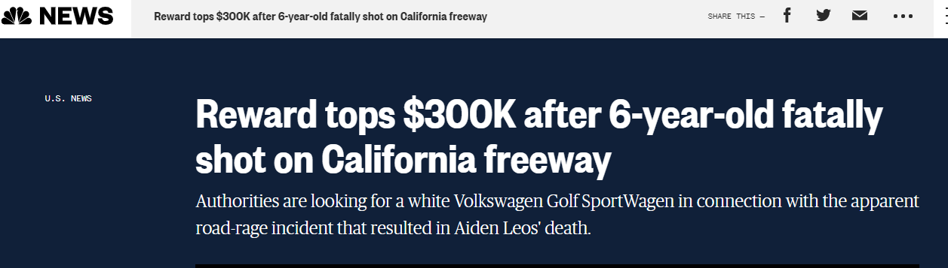
- The reader needs to take action due to an increase in road rage cases across various states in the country. The article asserts, "A reward fund has grown to more than $300,000 in the search for suspects in the apparent road-rage slaying of a 6-year-old boy in Southern California." The above information reveals that our roads are no longer safe, thus the need to take care whenever traveling. There is a need to install dash cameras that can capture all activities on the roads since some criminals tend to flee away after committing such crimes.
- There is an immediate threat to the public's safety since such attacks are unpredictable. The safety of children is greatly at stake. According to the article, "The boy, on his way to kindergarten, told his mother, "Mommy, my tummy hurts," immediately after he was shot, the family said." The above quote implies that the perpetrators of road crimes do not care whether there are children or not.
- Road rage has a significant effect on the community because it makes the roads unsafe at all times. People are not sure whether they will get back home.
- The publication of this story would help to prevent this crime. For instance, through this publication, witnesses can emerge and provide the police with adequate information to fasten the investigation and arrest of these criminals.
- This story aids in increasing public understanding of the crime since it enlightens drivers and other road users on possible road attacks.
- In conclusion, the article should have been published because it creates awareness on the issue of road-rage that has become a thorn in the flesh in American society.

News Article Four: Florida man charged with sex crimes against the 11-year-old girl who was missing for days

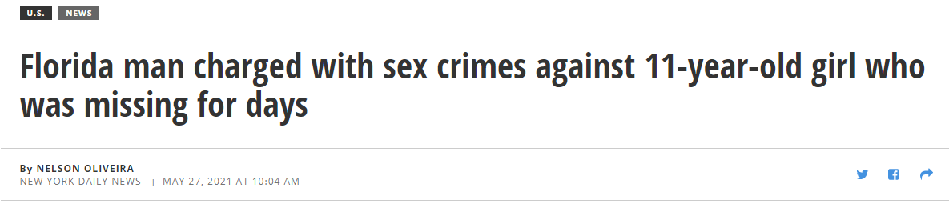

The reader needs to take action. The reader should take action because these criminals do not spare anyone in society. The reader should take action and circulate this message on other social media platforms. The news states, "A Florida man has been charged with multiple sex crimes after police learned he went to an 11-year-old's home, picked her up, and traveled with the child for several days." The above information depicts that these criminals target younger children, thus the need to protect these kids as possible.

There is an immediate threat to the safety of children in this country since varied criminals see them as sexual objects. Based on this news, "The suspect is accused of molesting her multiple times during the trip." Such acts threaten the lives of these children.

This crime has a significant effect on the community because it instills fear among the children. Children can no longer feel safe when left alone at home.

The publication of this story would help to prevent crimes of such kind because parents will be very cautious and grant their children adequate security.

The story helps to increase public understanding of the crime by explaining the possible effects of child kidnapping cases. For instance, it shows that such instances can lead to rape cases among children.

In conclusion, this article should have been published because it informs the audience on the safety of children.
News Article Five: Three Men Charged with Hate Crimes After Anti-Semitic Incidents in Brooklyn.
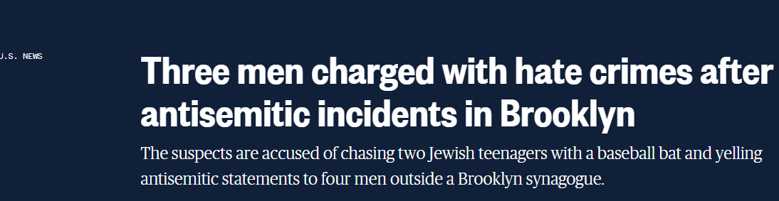
- The reader needs to take action. For instance, the reader should spread the news of love among all Americans. The news reveals, "Three men were charged with hate crimes after police said they yelled antisemitic statements to four people standing outside a New York synagogue, damaged a car, and attacked two Jewish teenagers.” The above information shows the impacts of hate crimes. For instance, such crimes do not only lead to loss of lives and bodily harm but also the destruction of property.
- This crime poses an immediate threat to public safety since it increases cases of violence. According to the news article, “The NYPD announced Tuesday that Danial Shaukat, 20, also of Brooklyn, was arrested on a charge of aggravated harassment as a hate crime.” The above quote proves that hate crime is a leading cause of violence and attacks in society.
- This crime is likely to have a significant effect on the community because it creates division among various ethnic groups.
- The publication of this story would help to reduce this crime because the perpetrators will understand the legal effects of their actions. For instance, this news reveals that such crimes are attached to heavy fines. The article states, "He has since been arraigned on additional charges, including assault as a hate crime and harassment, according to the Brooklyn District Attorney's Office. His bail was set at $5,000 or $2,500 case."
- This story helps to increase public understanding of the hate crimes against other minority groups in the country. It also shows various challenges that these communities encounter.
- Finally, this article should have been published because it is a way of discouraging hate crimes that have been rising this year.
News Article One: Times Square Shooting Suspect Charged with Attempted Murder
Times Square shooting suspect charged with attempted murder
Farrakhan Muhammad, 31, was also charged with assault, criminal use of a firearm endearment.
May 29, 2021, 11:30 PM EAT
By Minyvonne Burke
A man accused of injuring three people, including a child, when he opened fire in New York City's Times Square faces numerous charges, including attempted murder.
Farrakhan Muhammad, 31, was captured May 12 in a Florida McDonald's parking lot after police say he shot Wendy Magrinat, 23; Mạrcela Aldana, 43; and Skye Martinez, 4.
He made his initial court appearance virtually in Florida and requested a court-appointed attorney to help him through the extradition process, NBC New York reported.
The New York City Police Department confirmed Friday that Muhammad was in their custody. He's been charged with attempted murder, three counts of assault, four counts of criminal use of a firearm, and three counts of reckless endangerment.
Detectives believe that Muhammad was shooting at his brother near West 45th Street and 7th Avenue but missed and hit three people in the busy tourist center. Martinez was hit in the leg while shopping for toys with her family.
Magrinat was struck in the thigh and Aldana in the foot, according to authorities.
Police officers respond to the scene of a shooting in Times Square on May 8, 2021, in New York. David Dee Delgado / Getty Images
Days after the May 8 shooting, police identified Muhammad as the suspected shooter. Cameras helped investigators track him leaving Times Square, going to a hotel on 42nd Street, changing clothes, and heading out with his girlfriend.
Muhammad and his girlfriend, Kristine Vergara, were spotted May 11 at a Walmart in Fayetteville, North Carolina, before they were eventually found in Florida, police said.
The pair were confronted at a McDonald's in Starke, Florida, about 50 miles southwest of downtown Jacksonville. Law enforcement caught up with them as they ate in their car.
Vergara admitted during a court appearance earlier this month that she drove Muhammad south to evade police.
Attorney information was not available for Muhammad.
News Article Two: Woman Charged in Idaho Killing of her Children may face Arizona Charge in Death of Estranged Husband.
Police say a woman charged in Idaho with murder in the deaths of her daughter and son after their disappearances should face an additional criminal charge in suburban Phoenix in the 2019 killing of her estranged husband.
Meanwhile, Lori Vallow Daybell was declared not competent to stand trial in Idaho, according to an order filed Thursday morning in a Fremont, Idaho, County court. The Idaho Statesman reported Daybell now needs restorative treatment and must be returned to competency before her criminal case in Idaho can move forward. The order notes that prosecutors are contesting the outcome, and a hearing will be needed.
Investigators have recommended that prosecutors file a conspiracy to commit murder charge against Daybell in the death of Charles Vallow, who was killed in Chandler, Arizona, months before his son, 7-year-old Joshua "JJ" Vallow, and stepdaughter, 17-year-old Tylee Ryan, went missing.
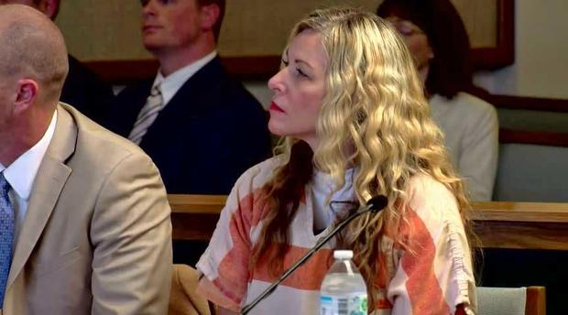On Lori Vallow Daybell's initial appearance in Rexburg, the courtroom was jam-packed.
The recommendation was revealed Thursday by the Chandler Police Department, which investigated the case. Jennifer Liewer, a spokeswoman for county prosecutors in metro Phoenix, said the agency hasn't set a deadline for determining whether to charge Daybell in Charles Vallow's death. Mark Means, a lawyer for Daybell in the Idaho case, didn't immediately return a call and email Thursday seeking comment on his client's behalf.

News Article Three: Reward Tops $300k After 6-year-old Fatally Shot on California Freeway.
By David K. Li
A reward fund has grown to more than $300,000 in the search for suspects in the apparent road-rage slaying of a 6-year-old boy in Southern California.
The "Who Shot Aiden?" effort stood at $325,000 by early Friday evening, a little more than a week after Aiden Leos was gunned down in the back seat of a car driven by his mother on State Route 55 near Chapman Avenue in the city of Orange, officials said.

Aiden Leos.Family photo
The boy, in a booster seat, and his mom were headed north on the Costa Mesa Freeway when a shot was fired about 8 a.m. PT May 21, possibly from a white Volkswagen Golf SportWagen, authorities said.
The boy, on his way to kindergarten, told his mother, "Mommy, my tummy hurts," immediately after he was shot, the family said.

Recommended

U.S. NEWSNashville hat shop hawks anti-vaccine yellow Star of David badge

U.S. NEWSAmerican Airlines extends alcohol service suspension after Southwest Airlines assault
The Golf had non-tinted windows and appeared to be a 2018 or 2019 model, authorities said. Two people were inside. The car was last seen heading toward eastbound State Route 91 shortly after the shooting, which investigators have labeled a case of road rage.
The attack happened about eight miles east of Disneyland and more than 30 miles southeast of downtown Los Angeles.

Yellow crime scene tape stretches across the northbound lanes of the 55 freeway as police investigators walk the freeway looking for evidence following a shooting on May 21, 2021, in Orange, Calif.Mark Rightmire / The Orange County Register via AP file.
"Please, if you saw anything, anything at all, any dashcam footage or something suspicious, please come forward," the boy's sister Alexis Cloonan pleaded on Thursday.
Orange County Supervisor Don Wagner, who represents the location where Aiden was shot, urged constituents to keep their ears open for any clues that might help investigators.
"Maybe you're hearing a neighbor, an acquaintance, talk about this horrible thing that they heard about that happened, that they know who did (it), whatever it happens to be, come forward," Wagner said.
David K. Li
David K. Li is a breaking news reporter for NBC News.
by Taboola
Sponsored Stories

News Article Four: Florida man charged with sex crimes against the 11-year-old girl who was missing for days
A Florida man has been charged with multiple sex crimes after police learned he went to an 11-year-old's home, picked her up, and traveled with the child for several days.
The investigation began in March following the victim’s disappearance and mysterious return to her Bay County home, authorities said in a news release Tuesday. The girl was reported missing on March 20, seven days after she was last seen, and she returned home on March 21, according to police.
A search of the child’s cellphone later showed her communicating with a 30-year-old man, identified as Cory Hutchinson, during the days that she was missing, police said. Their connection was not immediately disclosed to protect the victim’s privacy, but the case apparently involves some sort of custody dispute.
Police said Hutchinson traveled from Tampa to the child's home in the Panhandle, picked her up, took her to his Tampa apartment, and then traveled with her to several cities within Florida, including Orlando. The suspect is accused of molesting her multiple times during the trip.
News Article Five: Three Men Charged with Hate Crimes After Anti-Semitic Incidents in Brooklyn.
May 27, 2021, 6:26 PM EAT / Updated May 27, 2021, 7:17 PM EAT
By Elisha Fieldstadt
Three men were charged with hate crimes after police said they yelled antisemitic statements to four people standing outside a New York synagogue, damaged a car, and attacked two Jewish teenagers.
Haider Anjam, 20, and Ashan Azad, 19, both of Brooklyn, were arrested Wednesday on charges of harassment and aggravated harassment as a hate crime, according to the New York City Police Department.
Anjam faces an additional charge of menacing as a hate crime.
The NYPD announced Tuesday that Danial Shaukat, 20, also of Brooklyn, was arrested on a charge of aggravated harassment as a hate crime. He has since been arraigned on additional charges, including assault as a hate crime and harassment, according to the Brooklyn District Attorney's Office. His bail was set at $5,000 or $2,500 case.
It was not clear Thursday if the suspects had attorneys. Anjam and Azad had not been arraigned as of Thursday.
The men are accused of pulling up to Agudath Israel of Sixteenth Avenue in the Borough Park neighborhood of Brooklyn on Saturday night in a blue Toyota Camry and yelling "anti-Jewish statements" at a group of four men outside the synagogue, police said.
A criminal complaint said the men yelled, "Free Palestine. We'll kill all the Jews."

